**1..write the c program for linked list**

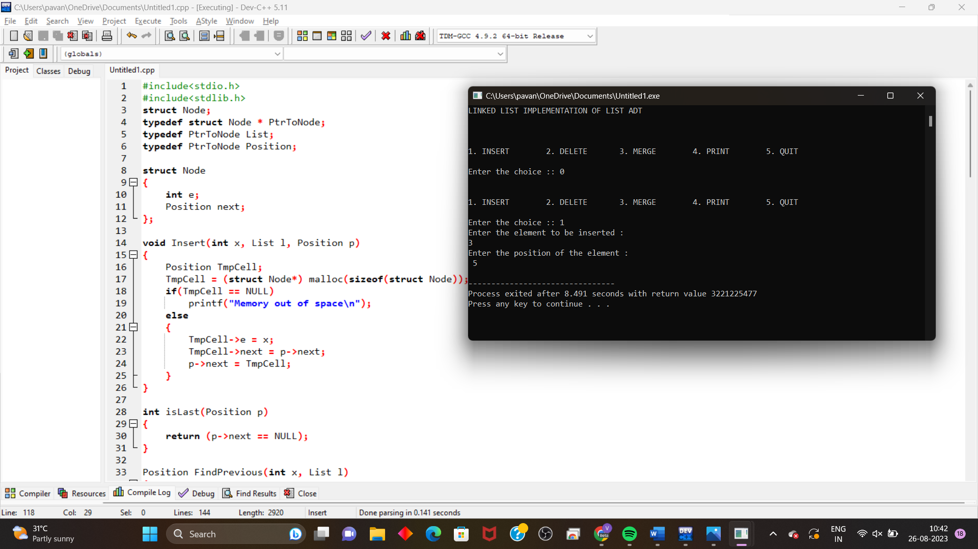

**2. write the c program to implement stack data structure push an element**

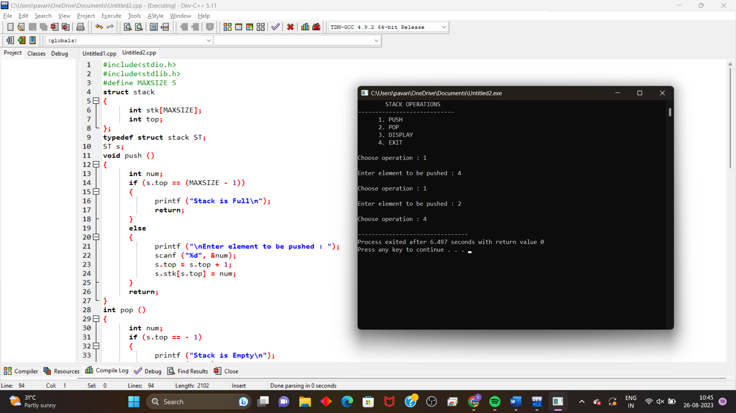

**3. write the c program to implement a data structure by enque, deque ,display.**

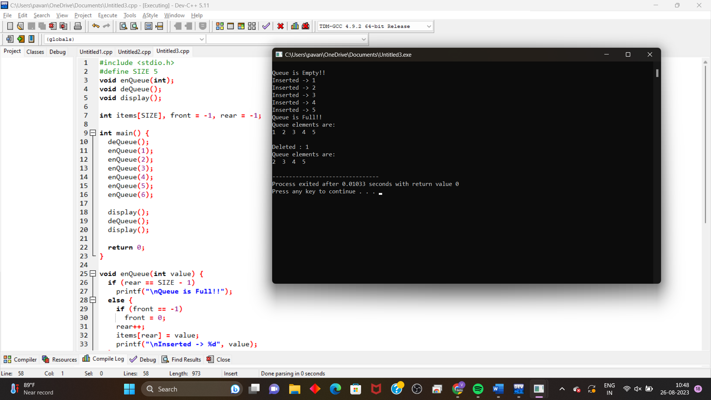

**4. write the c program to convert infix expression to prefix to postfix expression using stack.**

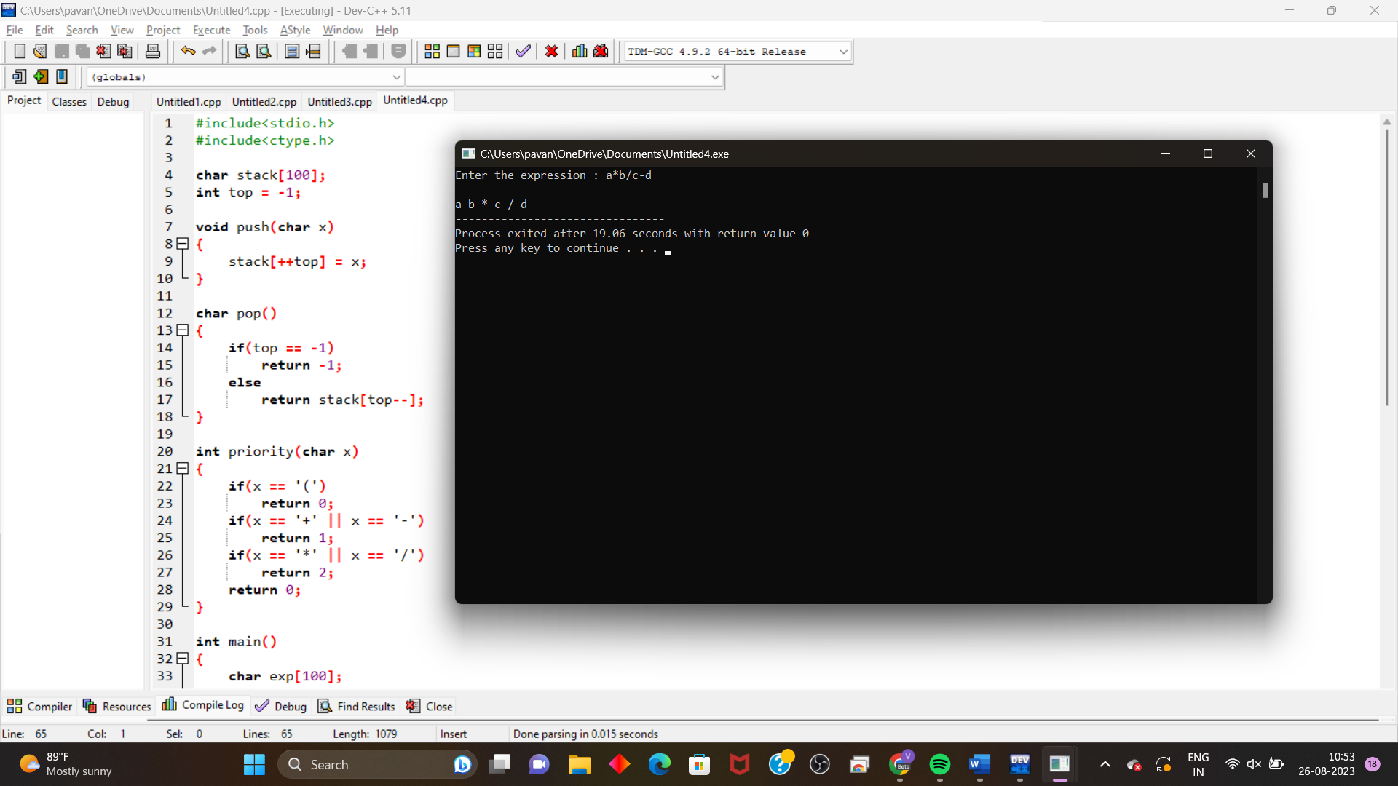

**5. write the c program to evaluate the expression using stack.**

